LED BLUE IS POSITIVE

LED GREEN IS NEGA

WRITING IS POSITIVE 🡪 HOT

NON WRITING IS NEGATIVE 🡪 NEUTRAL

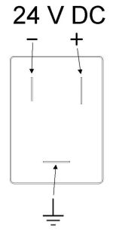 solenoid

